**Installing driver for Arduino Rev 3**

If the PC is not recognising the Arduino when it is connected, do the following:

* Go to <http://www.angstromdesigns.com/software/faq/130-why-wont-my-arduino-uno-rev3-work>
* After clicking on the link labelled ' [Click here to download the Arduino Uno Rev. 3 driver](http://www.angstromdesigns.com/files/Arduino%20UNO%20REV3.inf.zip) ', go to the save option for the zip file
* Extract the file to the \drivers\FTDI USB Drivers directory in file explorer in the Arduino folder

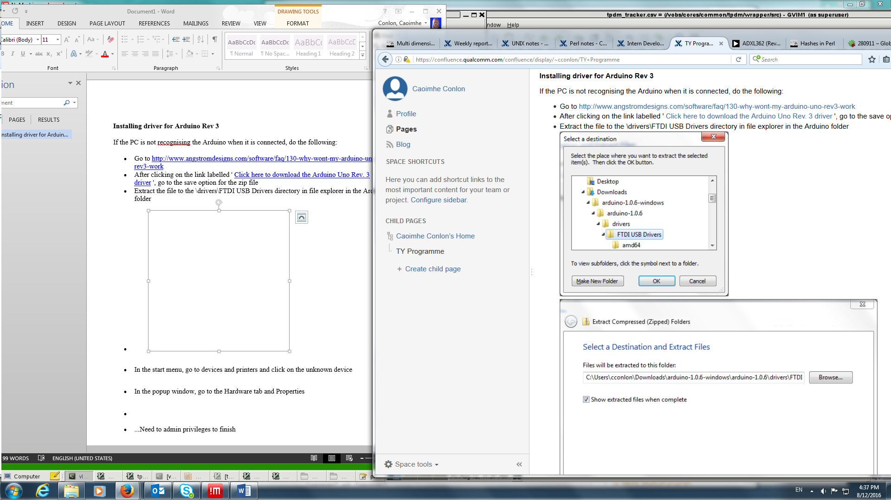

* In the start menu, go to devices and printers and right click on the unknown device which should be the Arduino
* In the popup window, go to the Hardware tab and Properties
* Click on Change Settings and then go to the Driver tab in the pop up
* Click Install driver and choose the \drivers\FTDI USB Drivers as the location